Nama : Ferry Amaludin

NIM :H1A021036

Link github

<https://github.com/ferryamludn2/DPP-denial-phishopers-pelican.git>

DPP (denial phishopers pelican)

Tesktual analysis

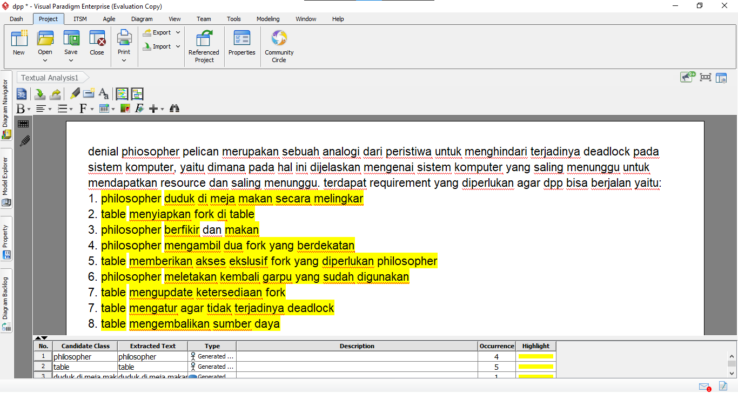

Use case diagram

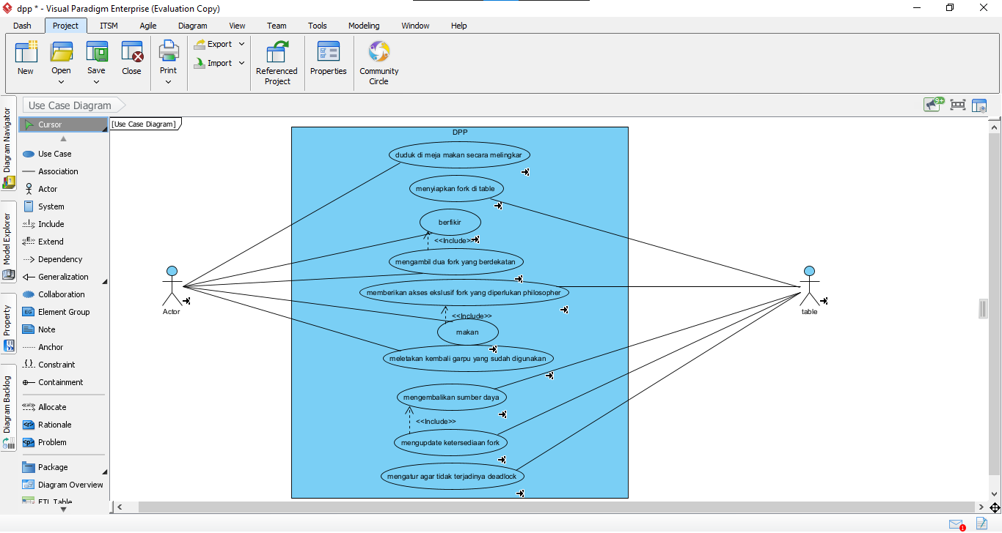

Class diagram

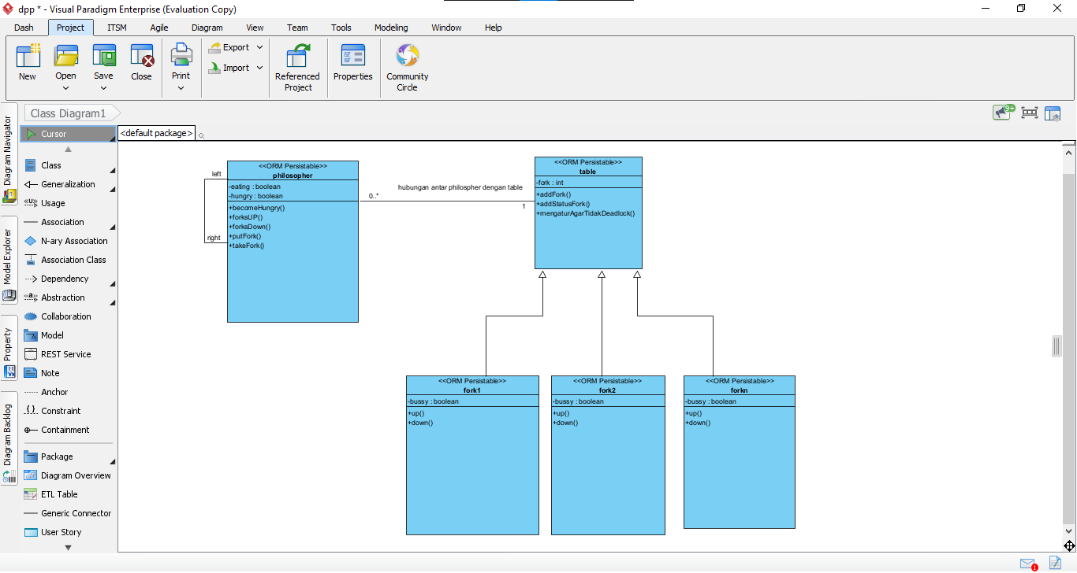

ERD

